2021 Produce CSA Application
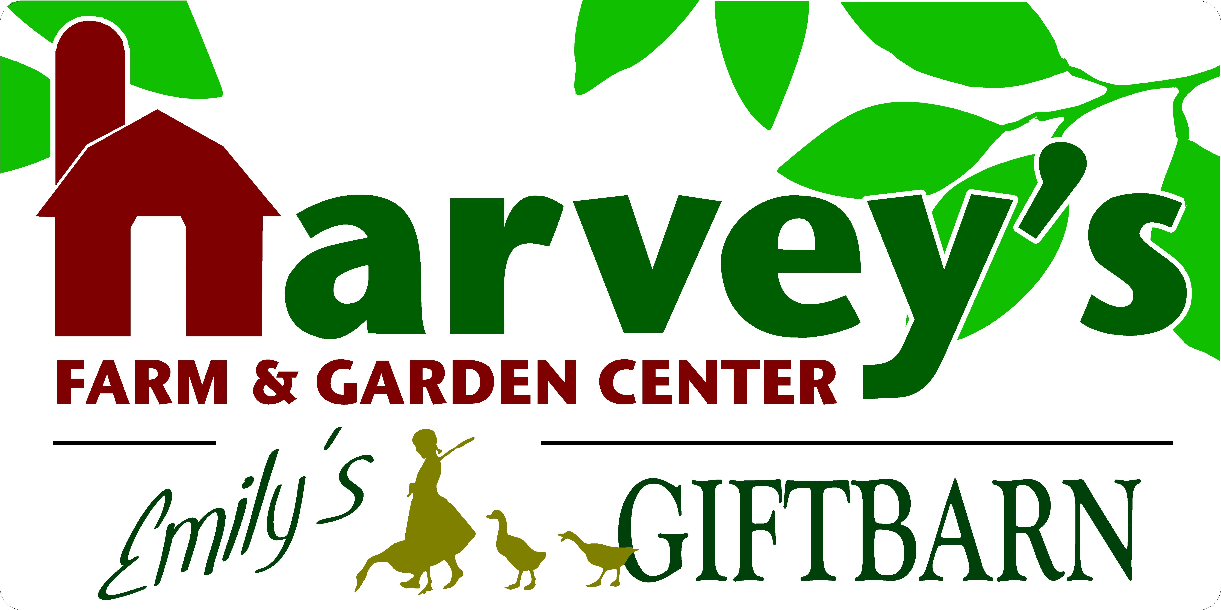
7 Maple Avenue • Westborough • 508-366-1545 • Emily@harveysfarm.com
Name:
Street Address:
City/Town:
Cell Phone: | Home Phone:
Email Address:
Alternate Pickup Name:
Alternate Phone Number(s):
Alternate Pickup Name:
Alternate Phone Number(s):
Program Options (Select One)

____ Full Share | 22 Consecutive Weeks | $750 Investment
Tuesdays | June 15, 2021 – November 9, 2021
___ 12-2pm Pickup
___ 2-5pm Pickup

Fridays | June 18, 2021 – November 12, 2021
___ 12-2pm Pickup
___ 2-5pm Pickup

____ Small Share| 22 Consecutive Weeks| $575 Investment
Tuesdays | June 15, 2021 – November 9, 2021
___ 12-2pm Pickup
___ 2-5pm Pickup

Fridays | June 18, 2021- November 12. 2021
___ 12-2pm Pickup
___ 2-5pm Pickup

____Payment Plan + $20 Additional Fee (Optional)
50% Payment Due by April 1, 2021
25% Payment Due by May 1, 2021
25% Payment Due by June 1, 2021
____Check Here if Interested in Extending Your Share on a Weekly Basis.
We’ll Contact You Towards the End of Your Scheduled Season
____ Check Here if Interested in Being Notified for Bulk Produce Availability, Such as Tomatoes for Canning.

Payment Information

____Check Made Payable to Harvey’s Farm | Check Preferred
Mail To: Harvey’s Farm | 120 South Street | Westborough, MA 01581

____Credit Card Do Not Email Credit Card Information | Staff Will Follow Up with you if emailing completed application. Visa and Master Card Preferred.

Credit Card # Exp Date CVC Code Zip Code

2021 Harvey’s Farm Produce CSA Shareholder Agreement
- I would like to join the Harvey’s Farm CSA program and receive my weekly share (as noted on application).
- I understand that I will share in the bounty and the risks involved with food production.
- I understand that if I am / authorized person is unable to pickup my share by closing time of the designated pickup day, I understand that my share will be forfeited.
- I understand that a minimum number of participants are required in order to run the CSA program. If the minimum is not met, you will be notified promptly and payment refunded. Please tell Your Friends to Join!

Signature: Date:

Email Your Application
Emily@harveysfarm.com
Staff Will Contact You for Payment Information if Paying by Credit Card
Payment by Check Can Be Mailed

Apply in Person During Normal Business Hours
Daily 10 – 5 | Wednesday 10 – 1 | Sunday 10 - 4
All Payments Accepted, Although Cash & Check Are Preferred

Application & Payment by Mail:
Harvey’s Farm
120 South Street
Westborough, MA 01581

2021 Produce CSA Program Details
Please Keep For Your Records
- Pickup Location: Harvey’s Farm | 7 Maple Avenue | Westborough
From Parking Lot, Enter through the Main Greenhouse under “Welcome” Sign, Walk up Hallway to Emily’s Gift Barn, where staff will assist you with pickup

- Please Note: Shares that are not picked up by closing on designated pickup day will be forfeited. We are unable to accommodate alternate pickup days and times, so please make arrangements at least 24 hours in advance if no one is able to pickup your share.

- Application and Payment: Must be submitted ASAP to reserve share. Payment by Cash or Check is preferable, Credit is accepted. Availability on a first come, first serve basis.

- Minimum number of participants are required in order to run the CSA program. If the minimum is not met, you will be notified promptly and payment refunded. Please tell Your Friends to Join!

- Risk & Reward: Just as you will share in he bounty of the harvest, you run the risk of sharing the challenges of crop loss due to unforeseeable circumstances including, but not limited to, weather.

What You’ll Receive
- A Reusable Basket filled with a variety of produce, based on seasonality and availability. Please Note: Basket/Tote MUST be returned at time of each pickup to avoid a $5 fee.

- The types of produce (vegetables, herbs, fruits) will vary depending on weather conditions, time of season and produce availability.

- In addition to produce, your share may include other items such as honey, eggs, baked goods, flowers & recipe ideas.

- By becoming a Harvey’s Farm Produce CSA member, you are committed to supporting a healthy lifestyle, local agriculture and your community. Thank you!

TUESDAY Pickup: Tuesday June 15, 2021 – Tuesday, November 9, 2021
or
FRIDAY Pickup: Friday, June 18, 2021 – Friday, November 12, 2021

12 – 2pm or 2- 5pm Pickup

