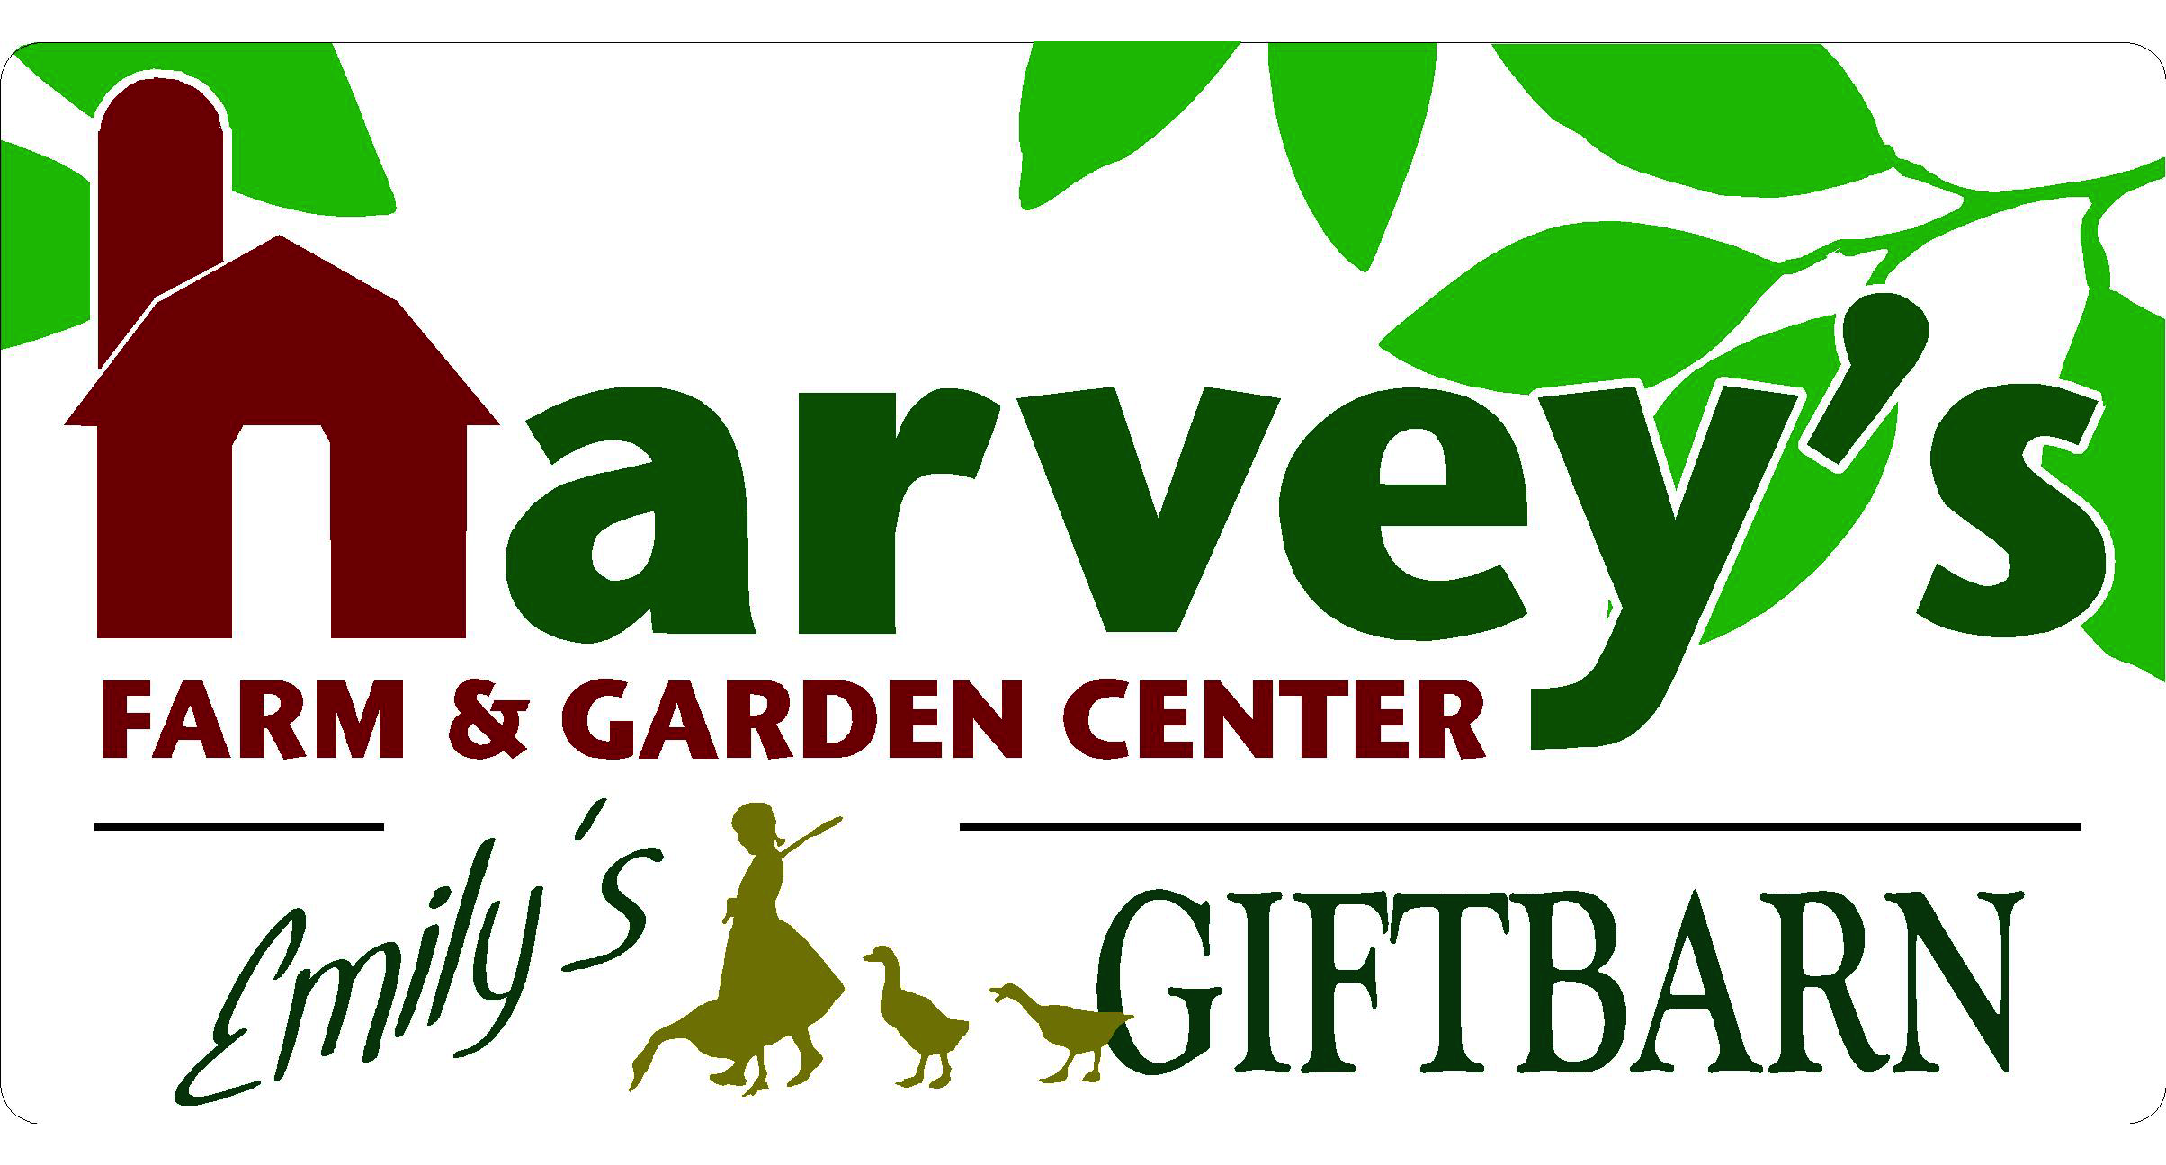
120 South Street Westborough, MA • 508-366-1545
harveysfarm.com • harveysfarm@yahoo.com

Veggie Gardening 101 “Cheat Sheet”

Location & Scale – Where Will Your Garden Be Located? How Big or Small?
- Movable Containers or Planted?
- The More Sun in the Area, the More Choices
- Start small and build on SUCCESS!
- Tall Plants (like tomatoes) on North Side of Garden, Don’t Save Space for Lettuce, use it as a “plug-in” crop in between your taller plants, the shade will help keep it cool & happier too!

Plant Selection & Sunlight-
- What Sunlight - Full Sun to Full Shade and everything in between, watch the area throughout the day and throughout the season
- What do you like to eat? How big is your family?

The “Dirt” About Soil – Soil Testing - When in doubt, find out!
- Essential Nutrients, Organic Matter & Texture, Horse Manure (no value)
- Nutrients & Calcium (water-soluble) need to be applied at least twice in a season
- Old, Compacted Dirt – Change It and Add Nutrients
- “Healthy Soil, Healthy Plants…Healthy You!” = Feed the Soil so it Feeds You

“Garden Cart Combo” - rated for approx 100-150ft² Other Options Available
- Peat Moss – Using an iron rake/pitch fork, break apart compressed bale of peat moss, spread evenly over entire garden
- Dehyrdrated Cow Manure- Use both bags, spread evenly over peat moss
- Chickity Doo Doo (pelletized chicken manure): sprinkle full bag over cow manure
- Pelletized Lime / Mag-i-Cal: Sprinkle full bag over chickity doo doo.
- Incorporate/Mix/Rototill
- Plant– There’s no sense in having a garden full of water-soluble nutrients, then it rains, and the nutrients aren’t feeding any plants
- Re-Apply Fertilizer & Lime- After 6-8 weeks (or more frequently if we have had a lot of rain)

**Other Animal-Free Products Available – Dr Earth Vegetable Planting Soil & Fertilizer and Mag-i-Cal (pelletized lime) will keep things organic and manure-free**

Watering- “A human with a hose is the kiss of death,” says Farmer Harvey
- The problem is Too much frequency, not enough volume of water – better to be out once/week for 30 mins than 7 days a week for 5 mins roots will follow the moisture deep healthier plants
- Containers vs. Planted in the ground – Are containers able to picked up to test weight? Most of a plant’s weight is the water – heavy = lots of moisture , light= may need a drink (depending on the plant)

“Feed Me” – Plants Need to be Fed, Just Like People
- Water-Soluble (necessary application every third watering) vs. Continuous-Release ( the “insurance policy”)
- Be sure to reapply fertilizer and lime at least twice or three times during a season. As the season progresses, it’s rained/you have watered, the plants have taken up nutrients and are getting bigger, but less nutrients are present in the soil…time to FEED & LIME!

Questions/Notes:

