2020 Produce CSA Application
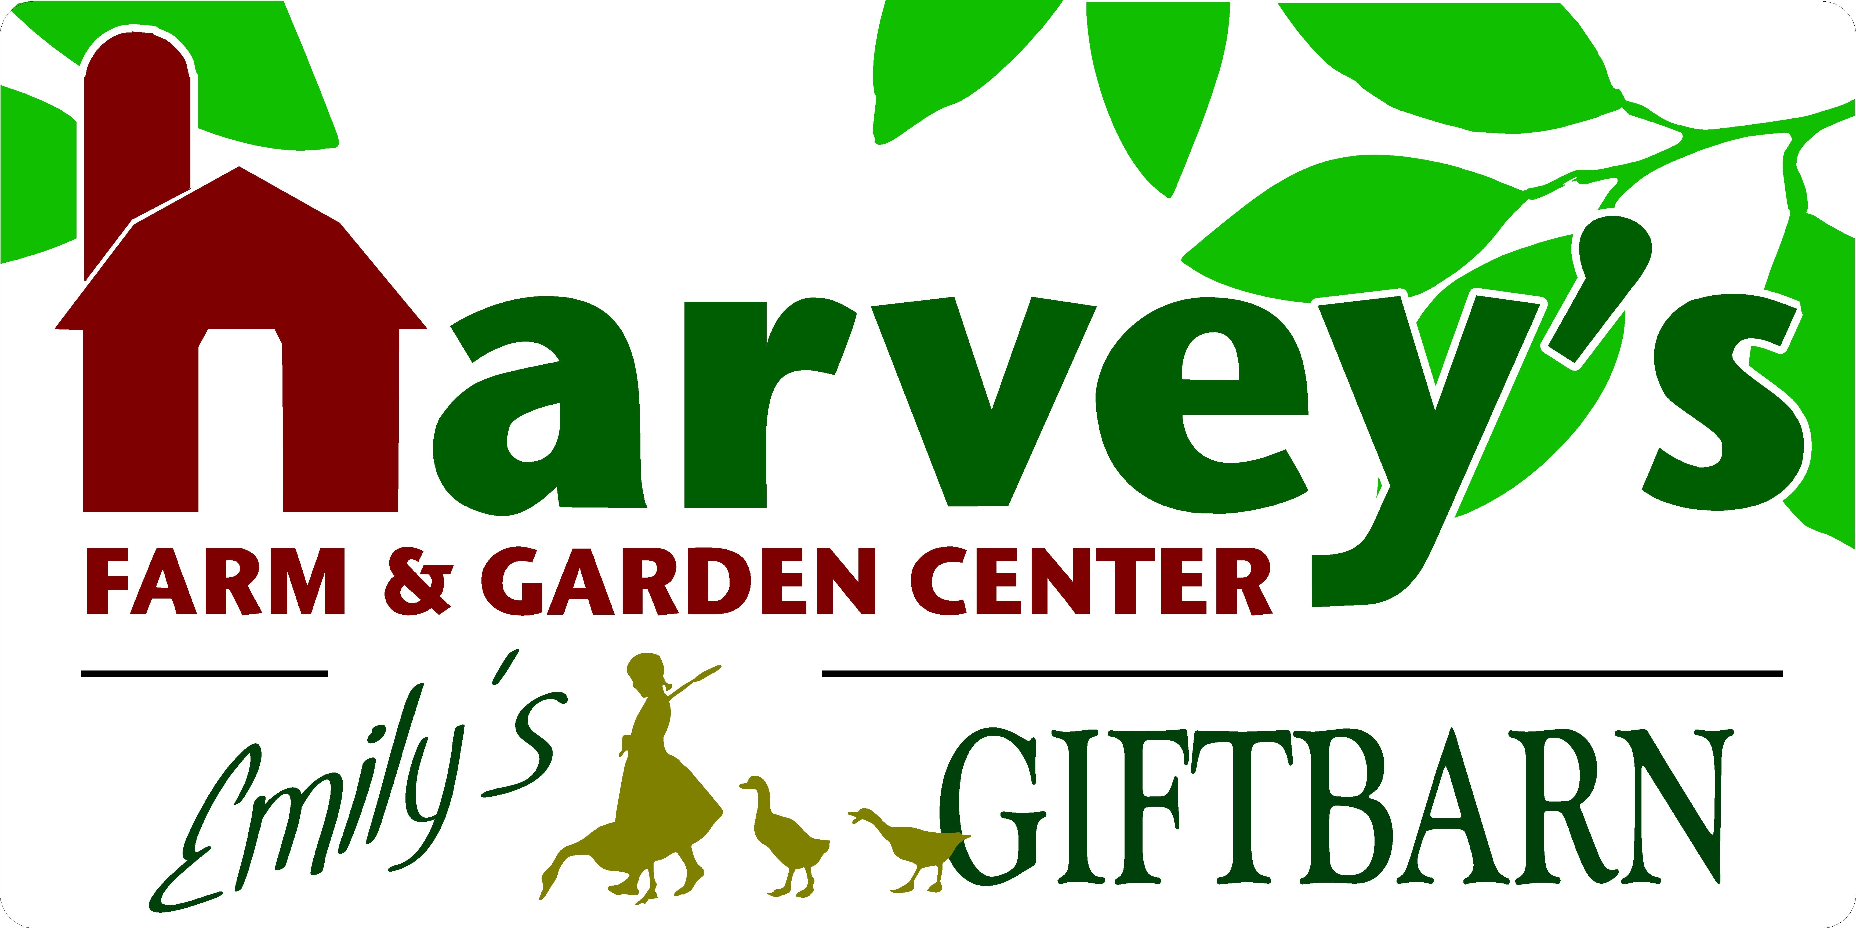
7 Maple Avenue • Westborough • 508-366-1545 • Emily@harveysfarm.com
Name:
Street Address:
City/Town:
Cell Phone: | Home Phone:
Email Address:
Alternate Pickup Name:
Alternate Phone Number(s):
Alternate Pickup Name:
Alternate Phone Number(s):
Program Options (Select One)

____Program A: Full Share | 22 Consecutive Weeks | $660
Tuesdays | June 16th – November 10th
___ 12-2pm Pickup
___ 2-5pm Pickup

____Program B: Small Share | 22 Consecutive Weeks | $500
Tuesdays | June 16th – November 10th
___ 12-2pm Pickup
___ 2-5pm Pickup

____FREE BUSHEL BUTTERNUT When Minimum $100 Deposit Paid by December 1, 2019

____ FREE Jam/Jelly/Preserve of Your Choice When Balance Paid by December 30, 2019 Up to $5.99 Value

____Payment Plan + $15 Additional Fee (Optional)
50% Payment Due by April 1, 2020
25% Payment Due by May 1, 2020
25% Payment Due by June 1, 2020

____Check Here if Interested in Extending Your Share on a Weekly Basis. We’ll Contact You Towards the End of Your Scheduled Season

____ Check Here if Interested in Being Notified for Bulk Produce Availability, Such as Tomatoes for Canning.

Payment Information

____Check Made Payable to Harvey’s Farm | Check Preferred
Mail To: Harvey’s Farm | 120 South Street | Westborough, MA 01581

____Credit Card Do Not Email Credit Card Information | Staff Will Follow Up with you if emailing completed application. Visa and Master Card Preferred.

Credit Card # Exp Date CVC Code Zip Code

2020 Harvey’s Farm Produce CSA Shareholder Agreement
- I would like to join the Harvey’s Farm CSA program and receive my weekly share (as noted on application).
- I understand that I will share in the bounty and the risks involved with food production.
- I understand that if I am / authorized person is unable to pickup my share by closing time of the designated pickup day, I understand that my share will be forfeited.
- I understand that a minimum number of participants are required in order to run the CSA program. If the minimum is not met, you will be notified promptly and payment refunded. Please tell Your Friends to Join!

Signature: Date:

Email Your Application
Emily@harveysfarm.com
Staff Will Contact You for Payment Information if Paying by Credit Card
Payment by Check Can Be Mailed

Apply in Person During Normal Business Hours
All Payments Accepted, Although Cash & Check Are Preferred

Application & Payment by Mail:
Harvey’s Farm
120 South Street
Westborough, MA 01581

2020 Produce CSA Program Details
Please Keep For Your Records
- Pickup Location: Harvey’s Farm | 7 Maple Avenue | Westborough
From Parking Lot, Enter through the Main Greenhouse under “Welcome” Sign, Walk up Hallway to Emily’s Gift Barn, where staff will assist you with pickup

- Please Note: Shares that are not picked up by closing on designated pickup day will be forfeited. We are unable to accommodate alternate pickup days and times, so please make arrangements at least 24 hours in advance if no one is able to pickup your share.

- Application and Payment: Must be submitted ASAP to reserve share. Payment by Cash or Check is preferable, Credit is accepted. Availability on a first come, first serve basis.

- Minimum number of participants are required in order to run the CSA program. If the minimum is not met, you will be notified promptly and payment refunded. Please tell Your Friends to Join!

- Risk & Reward: Just as you will share in he bounty of the harvest, you run the risk of sharing the challenges of crop loss due to unforeseeable circumstances including, but not limited to, weather.

What You’ll Receive
- A Reusable Basket/ Tote filled with a variety of produce, based on seasonality and availability. Please Note: Basket/Tote MUST be returned at time of each pickup to avoid a $5 fee.

- The types of produce (vegetables, herbs, fruits) will vary depending on weather conditions, time of season and produce availability.

- In addition to produce, your share may include other items such as honey, eggs, baked goods, flowers & recipe ideas.

- By becoming a Harvey’s Farm Produce CSA member, you are committed to supporting a healthy lifestyle, local agriculture and your community. Thank you!

For Your Records

Program Options (Select One)

____Program A: Full Share | 22 Consecutive Weeks | $660
Tuesdays | June 16th – November 10th
___ 12-2pm Pickup
___ 2-5pm Pickup

____Program B: Small Share | 25 Consecutive Weeks | $500
Tuesdays | June 16th – November 10th
___ 12-2pm Pickup
___ 2-5pm Pickup

____Payment Plan + $15 Additional Fee (Optional)
50% Payment Due by April 1, 2020
25% Payment Due by May 1, 2020
25% Payment Due by June 1, 2020

FREE BUSHEL BUTTERNUT When Minimum $100 Deposit Paid by December 1, 2019

____ FREE Jam/Jelly/Preserve of Your Choice When Balance Paid by December 30, 2019 Up to $5.99 Value

____Check Here if Interested in Extending Your Share on a Weekly Basis. We’ll Contact You Towards the End of Your Scheduled Season
Payment Information

____ Check Here if Interested in Being Notified for Bulk Produce Availability, Such as Tomatoes for Canning.

